Your Title
YOUR NAME
2025-06-03
Abstract
Background: (Brief few sentences) Objectives: 1. Estimate the causal effect of YOUR EXPOSURE on YOUR OUTCOMES measured one year later. 2. Evaluate whether these effects vary across the population. 3. Provide policy guidance on which individuals might benefit most. Method: We conducted a three-wave retrospective cohort study (waves XX-XXX, October XXXX–October XXXX) using data SIMULATED from the New Zealand Attitudes and Values Study, a nationally representative panel. Participants were eligible if they participated in the NZAVS in the baseline wave (XXXX,…). We defined the exposure as (XXXX > NUMBER on a 1-7 Likert Scale (1 = yes, 0 = no)). To address attrition, we applied inverse probability of censoring weights; to improve external validity, we applied weights to the population distribution of Age, Ethnicity, and Gender. We computed expected mean outcomes for the population in each exposure condition (high XXXX/low XXXXX). Under standard causal assumptions of unconfoundedness, the contrast provides an unbiased average treatment effect. We then used causal forests to detect heterogeneity in these effects and employed policy tree algorithms to identify individuals (“strong responders”) likely to experience the greatest benefits. Results: Increasing XXXXX leads to XXXXX. Heterogeneous responses to (e.g. Forgiveness, Personal Well-Being, and Life-Satisfaction…) reveal structural variability in subpopulations… Implications: (Brief few sentences) Keywords: Causal Inference; Cross-validation; Distress; Employment; Longitudinal; Machine Learning; Religion; Semi-parametric; Targeted Learning.

Introduction
Your place to shine here

Method

Results

Average Treatment Effects
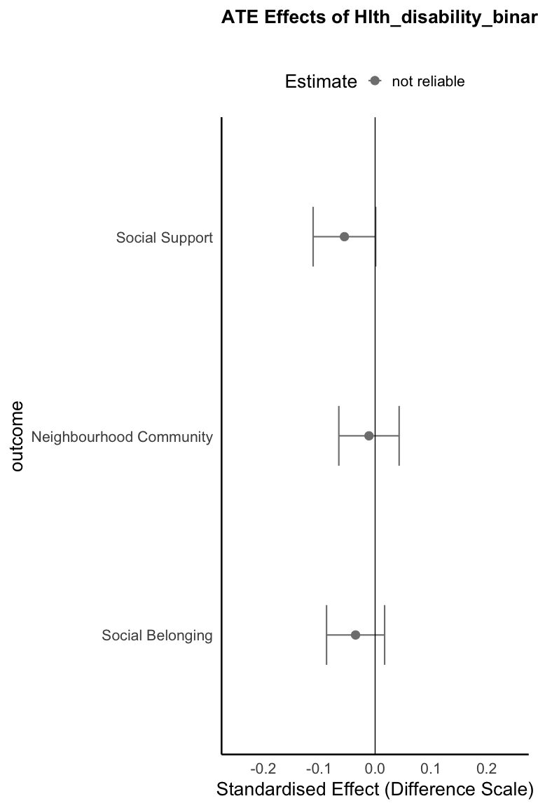
Figure 1: Average Treatment Effects on Multi-dimensional Wellbeing

Table 1: Average Treatment Effects on Multi-dimensional Wellbeing
Outcome | ATE | 2.5 % | 97.5 % | E-Value | E-Value bound
Social Support | -0.055 | -0.111 | 0.001 | 1.284 | 1
Neighbourhood Community | -0.011 | -0.065 | 0.043 | 1.111 | 1
Social Belonging | -0.035 | -0.087 | 0.017 | 1.215 | 1

Confidence intervals were adjusted for multiple comparisons using bonferroni correction ($α$ = 0.05). E‑values were also adjusted using bonferroni correction ($α$ = 0.05).

Heterogeneous Treatment Effects
We begin by examining the distribution of individual treatment effects (τᵢ) across our sample. Figure 2 presents the estimated treatment effects for each individual, revealing substantial variability in how people respond to {name_exposure_lower}.
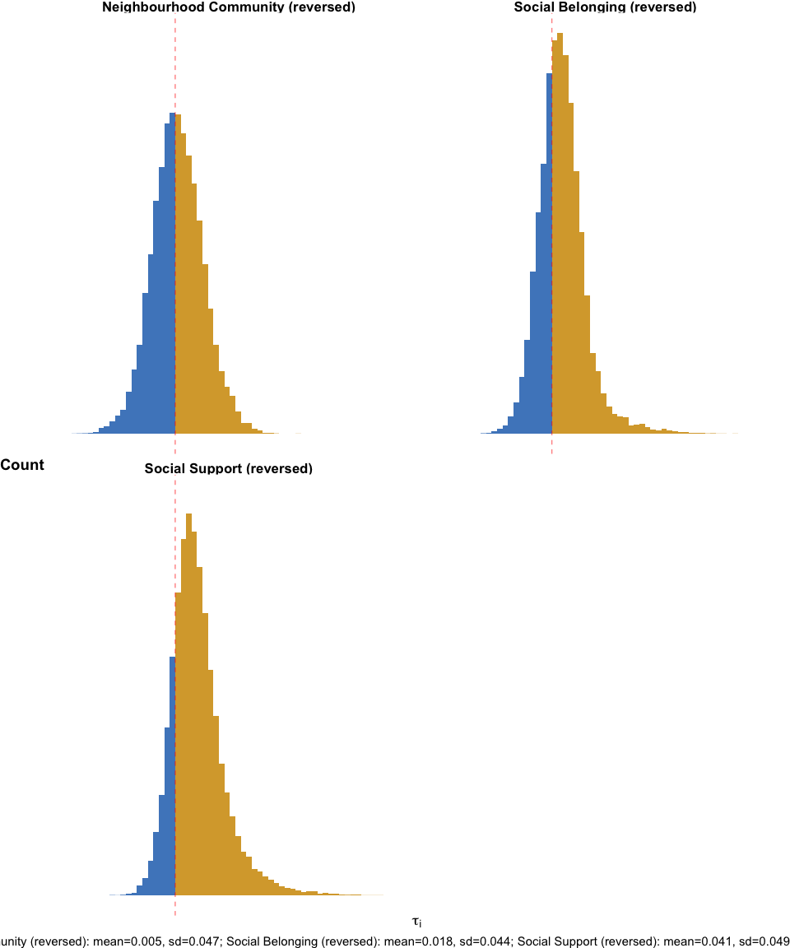
Figure 2: Distribution of Individual Treatment Effects (τᵢ) Across Outcomes
The histograms above show considerable heterogeneity in treatment effects across individuals. To determine whether this variability is systematic (i.e., predictable based on individual characteristics) rather than random noise, we employ two complementary approaches: Qini curves to assess the reliability of heterogeneous effects, and policy trees to identify subgroups with differential treatment responses.
*Note: Qini curve table only displayed when multiple significant results are found.*
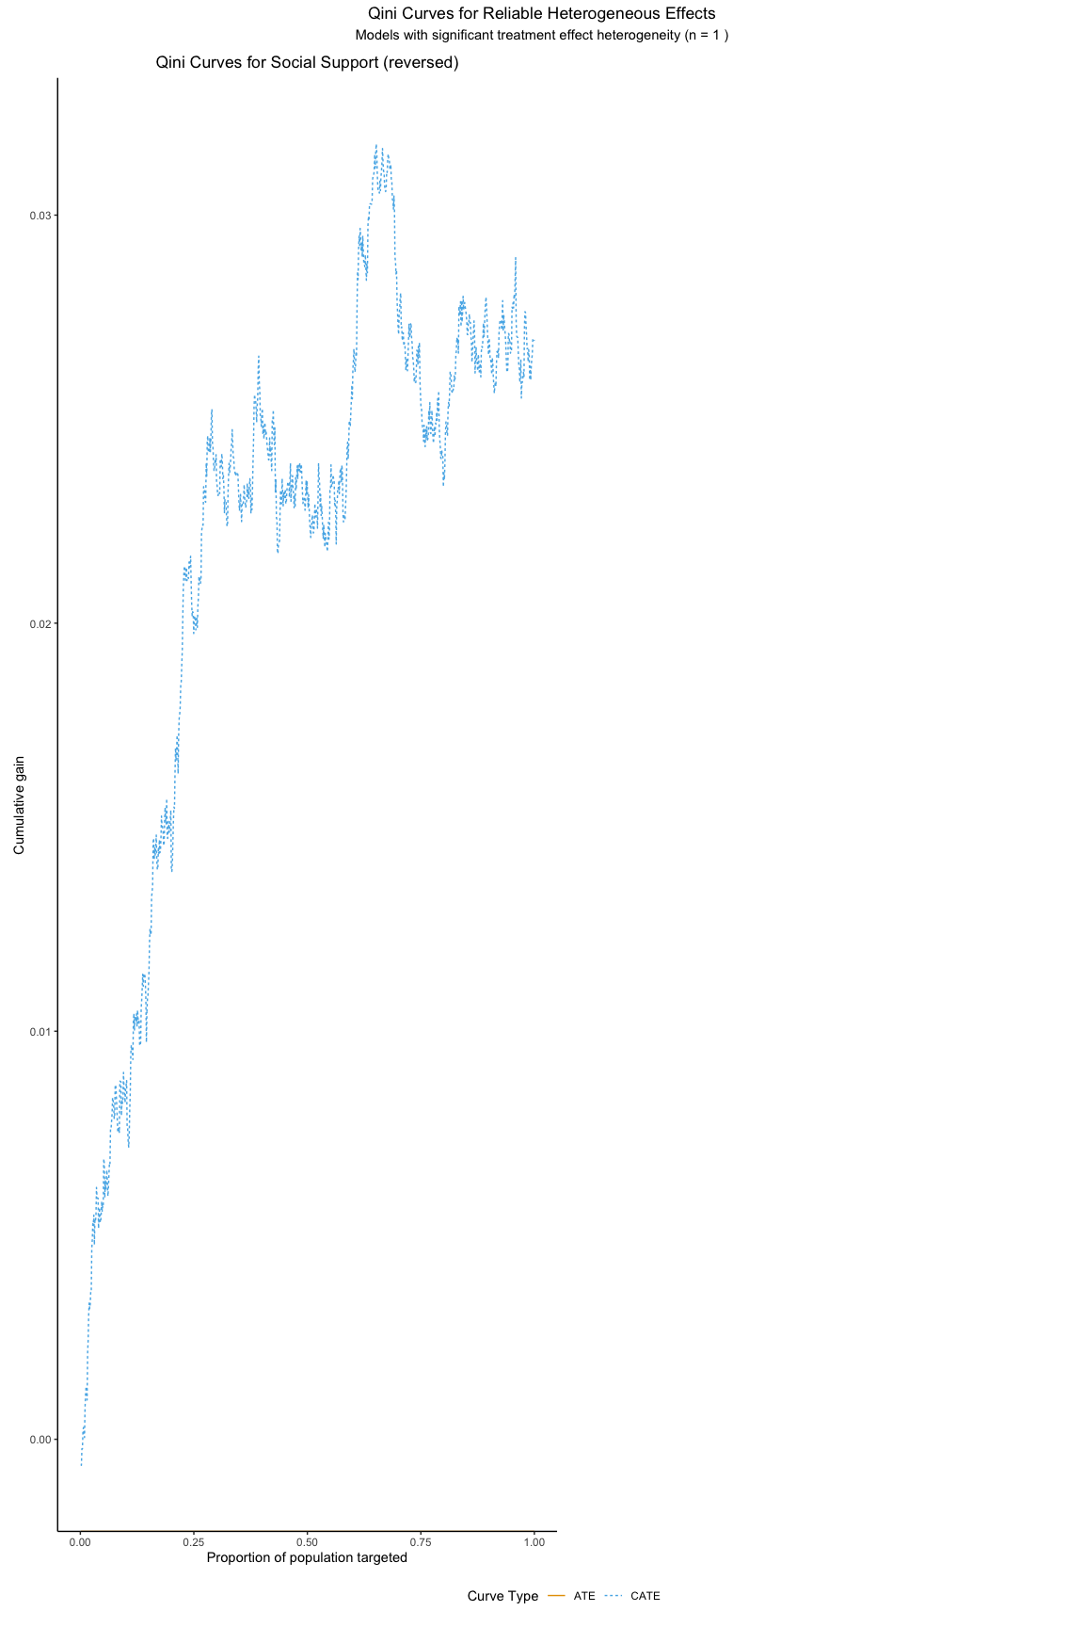
Figure 3: Qini Curves for Heterogeneous Treatment Effects

Decision Rules (Who is Most Sensitive to Treatment?)
The following pages present policy trees for each outcome with reliable heterogeneous effects. Each tree shows: (1) the decision rules for treatment assignment, (2) the distribution of treatment effects across subgroups, and (3) visual representation of how covariates split the population into groups with differential treatment responses.
#### Policy Tree 1: Social Support (reversed)
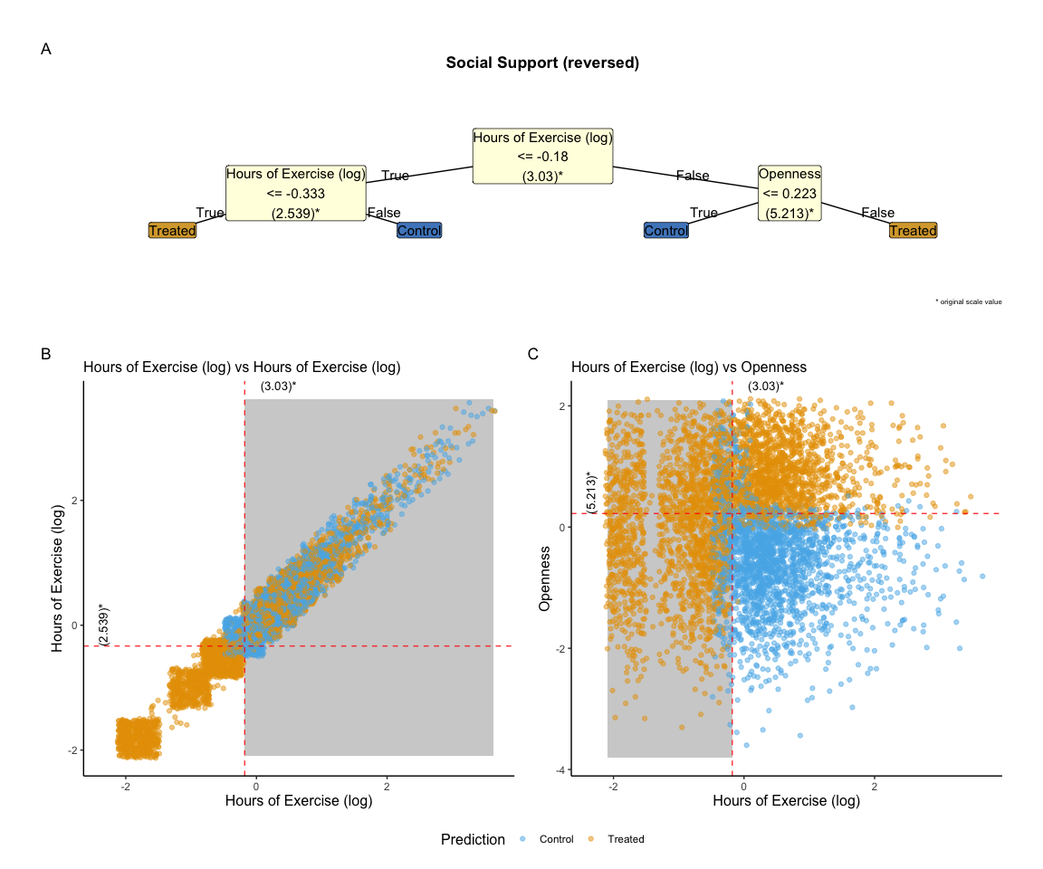
Figure 4: Policy Trees for Treatment Assignment

Discussion

Appendix A: Measures

Measures

Baseline Covariate Measures

Baseline Covariates

Age
We asked participants’ ages in an open-ended question (“What is your age?” or “What is your date of birth”) (Sibley, 2021).
Items:
- What is your date of birth?

Agreeableness
Mini-IPIP6 Agreeableness dimension: (i) I sympathize with others’ feelings. (ii) I am not interested in other people’s problems. (r) (iii) I feel others’ emotions. (iv) I am not really interested in others. (r) (Sibley et al., 2011).
Items:
- I sympathize with others’ feelings.
- I am not interested in other people’s problems.
- I feel others’ emotions.
- I am not really interested in others (reversed).

Alcohol Frequency
Participants could chose between the following responses: ‘(1 = Never - I don’t drink, 2 = Monthly or less, 3 = Up to 4 times a month, 4 = Up to 3 times a week, 5 = 4 or more times a week, 6 = Don’t know)’ (Health, 2013).
Items:
- “How often do you have a drink containing alcohol?”

Alcohol Intensity
Participants responded using an open-ended box (Health, 2013).
Items:
- “How many drinks containing alcohol do you have on a typical day when drinking alcohol? (number of drinks on a typical day when drinking)”

Social Belonging
We assessed felt belongingness with three items adapted from the Sense of Belonging Instrument (Hagerty & Patusky, 1995): (1) “Know that people in my life accept and value me”; (2) “Feel like an outsider”; (3) “Know that people around me share my attitudes and beliefs”. Participants responded on a scale from 1 (Very Inaccurate) to 7 (Very Accurate). The second item was reversely coded (Hagerty & Patusky, 1995).
Items:
- Know that people in my life accept and value me.
- Feel like an outsider (reversed).
- Know that people around me share my attitudes and beliefs.

Born in NZ
Coded binary (1 = New Zealand; 0 = elsewhere.) (Sibley, 2021).
Items:
- Where were you born? (please be specific, e.g., which town/city?)

Conscientiousness
Mini-IPIP6 Conscientiousness dimension: (i) I get chores done right away. (ii) I like order. (iii) I make a mess of things. (r) (iv) I often forget to put things back in their proper place. (r) (Sibley et al., 2011).
Items:
- I get chores done right away.
- I like order.
- I make a mess of things.
- I often forget to put things back in their proper place.

Education Level
We asked participants, “What is your highest level of qualification?”. We coded participans highest finished degree according to the New Zealand Qualifications Authority. Ordinal-Rank 0-10 NZREG codes (with overseas school qualifications coded as Level 3, and all other ancillary categories coded as missing) (Sibley, 2021).
Items:
- What is your highest level of qualification?

Employed
Binary response: (0 = No, 1 = Yes) (Statistics New Zealand, 2017).
Items:
- Are you currently employed (This includes self-employed of casual work)?

Ethnicity
Coded string: (1 = New Zealand European; 2 = Māori; 3 = Pacific; 4 = Asian) (Statistics New Zealand, 2017).
Items:
- Which ethnic group(s) do you belong to?

Disability Status
We assessed disability with a one-item indicator adapted from Verbrugge (1997). It asks, “Do you have a health condition or disability that limits you and that has lasted for 6+ months?” (1 = Yes, 0 = No) (Verbrugge, 1997).
Items:
- Do you have a health condition or disability that limits you and that has lasted for 6+ months?

Fatigue
Response scale: 0 = None Of The Time; 1 = A Little Of The Time; 2= Some Of The Time; 3 = Most Of The Time; 4 = All Of The Time
- During the last 30 days, how often did … you feel exhausted?

Anxiety
Response scale: 0 = None Of The Time; 1 = A Little Of The Time; 2= Some Of The Time; 3 = Most Of The Time; 4 = All Of The Time
- During the past 30 days, how often did…you feel restless or fidgety?
- During the past 30 days, how often did…you feel that everything was an effort?
- During the past 30 days, how often did…you feel nervous?

Depression
Response scale: 0 = None Of The Time; 1 = A Little Of The Time; 2= Some Of The Time; 3 = Most Of The Time; 4 = All Of The Time
- During the past 30 days, how often did…you feel hopeless?
- During the past 30 days, how often did…you feel so depressed that nothing could cheer you up?
- During the past 30 days, how often did…you feel you feel restless or fidgety?

log Hours with Children
We took the natural log of the response + 1 (Sibley et al., 2011).
Items:
- Hours spent…looking after children.

log Hours Commuting
We took the natural log of the response + 1 (Sibley, 2021).
Items:
- Hours spent…travelling/commuting.

log Hours of Exercise
We took the natural log of the response + 1 (Sibley et al., 2011).
Items:
- Hours spent…exercising/physical activity.

log Hours on Housework
We took the natural log of the response + 1 (Sibley et al., 2011).
Items:
- Hours spent…housework/cooking.

log Household Income
We took the natural log of the response + 1 (Sibley, 2021).
Items:
- Please estimate your total household income (before tax) for the year XXXX.

Male
Here, we coded all those who responded as Male as 1, and those who did not as 0 (Fraser et al., 2020).
Items:
- We asked participants’ gender in an open-ended question: “what is your gender?”

Neuroticism
Mini-IPIP6 Neuroticism dimension: (i) I have frequent mood swings. (ii) I am relaxed most of the time. (r) (iii) I get upset easily. (iv) I seldom feel blue. (r) (Sibley et al., 2011).
Items:
- I have frequent mood swings.
- I am relaxed most of the time (reversed).
- I get upset easily.
- I seldom feel blue (reversed).

Non Heterosexual
Open-ended question, coded as binary (not heterosexual = 1) (Greaves et al., 2017).
Items:
- How would you describe your sexual orientation? (e.g., heterosexual, homosexual, straight, gay, lesbian, bisexual, etc.)

NZ Deprivation Index
Numerical: (1-10) (Atkinson et al., 2019).
Items:
- New Zealand Deprivation - Decile Index - Using 2018 Census Data

Occupational Prestige Index
This index uses the income, age, and education of a reference group, in this case, the 2013 New Zealand census, to calculate a score for each occupational group. Scores range from 10 (Lowest) to 90 (Highest). This list of index scores for occupational groups was used to assign each participant a NZSEI-13 score based on their occupation (Fahy et al., 2017).
Items:
- We assessed occupational prestige and status using the New Zealand Socio-economic Index 13 (NZSEI-13).

Openness
Mini-IPIP6 Openness to Experience dimension: (i) I have a vivid imagination. (ii) I have difficulty understanding abstract ideas. (r) (iii) I do not have a good imagination. (r) (iv) I am not interested in abstract ideas. (r) (Sibley et al., 2011).
Items:
- I have a vivid imagination.
- I have difficulty understanding abstract ideas (reversed).
- I do not have a good imagination (reversed).
- I am not interested in abstract ideas (reversed).

Parent
Parents were coded as 1, while the others were coded as 0 (Sibley, 2021).
Items:
- If you are a parent, in which year was your eldest child born?

Has Partner
Coded as binary (has partner = 1) (Sibley, 2021).
Items:
- What is your relationship status? (e.g., single, married, de-facto, civil union, widowed, living together, etc.)

Political Conservatism
Response scale: 1 = Extremely Liberal, 7 = Extremely Conservative
- Please rate how politically liberal versus conservative you see yourself as being.

Major Religions
Open-ended (string). Coded from New Zealand Census Categories. Levels are: “Not Religious”,“Anglican”,“Buddhist”, “Catholic”, “Christian (Non-Denominational)”, “Christian (Other Denominations)”,“Hindu”, “Jewish”, “Muslim”,“Presbyterian, Congregational, Reformed”, “Other Religions” (Sibley, 2021).
Items:
- Do you identify with a religion and/or spiritual group? –> (If yes…)–> What religion or spiritual group?

Religious Identification
Response scale: 1 = Not Important, 7 = Very Important
- How important is your religion to how you see yourself?

Rumination
Ordinal responses: 0 = None of The Time, 1 = A little of The Time, 2 = Some of The Time, 3 = Most of The Time, 4 = All of The Time (Nolen-hoeksema & Morrow, 1993).
Items:
- During the last 30 days, how often did…you have negative thoughts that repeated over and over?

Rural Classification
“Participants residence locations were coded according to a five-level ordinal categorisation ranging from Urban to Rural.” (Whitehead et al., 2023).
Items:
- High Urban Accessibility = 1, Medium Urban Accessibility = 2, Low Urban Accessibility = 3, Remote = 4, Very Remote = 5.

Sample Frame Opt in
Code string (Binary): (0 = No, 1 = Yes) (Sibley, 2021).
Items:
- Participant was not randomly sampled from the New Zealand Electoral Roll.

Short Form Health
Response scale: 1 = Poor, 7 = Excellent
- In general, would you say your health is…

Smoker
Binary smoking indicator (0 = No, 1 = Yes) (Sibley, 2021).
Items:
- Do you currently smoke tobacco cigarettes?

Exposure Measures

Exposure Variable

Disability Status
We assessed disability with a one-item indicator adapted from Verbrugge (1997). It asks, “Do you have a health condition or disability that limits you and that has lasted for 6+ months?” (1 = Yes, 0 = No) (Verbrugge, 1997).
Items:
- Do you have a health condition or disability that limits you and that has lasted for 6+ months?

Outcome Measures

Outcome Variables

Social Belonging
We assessed felt belongingness with three items adapted from the Sense of Belonging Instrument (Hagerty & Patusky, 1995): (1) “Know that people in my life accept and value me”; (2) “Feel like an outsider”; (3) “Know that people around me share my attitudes and beliefs”. Participants responded on a scale from 1 (Very Inaccurate) to 7 (Very Accurate). The second item was reversely coded (Hagerty & Patusky, 1995).
Items:
- Know that people in my life accept and value me.
- Feel like an outsider (reversed).
- Know that people around me share my attitudes and beliefs.

Neighbourhood Community
(Sengupta et al., 2013).
Response scale: 1 = Strongly Disagree to 7 = Strongly Agree
Items:
- I feel a sense of community with others in my local neighbourhood.

Social Support
Response scale: 1 = Strongly Disagree, 7 = Strongly Agree
- There are people I can depend on to help me if I really need it.
- There is no one I can turn to for guidance in times of stress (reversed).
- I know there are people I can turn to when I need help.

Appendix B: Sample Characteristics

Sample Statistics: Baseline Covariates
Table 2 presents sample demographic statistics.
Table 2: Demographic statistics for New Zealand Attitudes and Values Cohort: {baseline_wave_glued}.
 | 2018
 | (N=39232)
Age
Mean (SD) | 48.5 (13.9)
Median [Min, Max] | 51.0 [18.0, 97.0]
Agreeableness
Mean (SD) | 5.35 (0.985)
Median [Min, Max] | 5.47 [1.00, 7.00]
Missing | 351 (0.9%)
Alcohol Frequency
Mean (SD) | 2.16 (1.34)
Median [Min, Max] | 2.00 [0, 5.00]
Missing | 605 (1.5%)
Alcohol Intensity
Mean (SD) | 2.15 (2.09)
Median [Min, Max] | 2.00 [0, 15.0]
Missing | 1627 (4.1%)
Belong
Mean (SD) | 5.14 (1.07)
Median [Min, Max] | 5.31 [1.00, 7.00]
Missing | 347 (0.9%)
Born in NZ
0 | 8401 (21.4%)
1 | 30381 (77.4%)
Missing | 450 (1.1%)
Conscientiousness
Mean (SD) | 5.10 (1.06)
Median [Min, Max] | 5.23 [1.00, 7.00]
Missing | 342 (0.9%)
Education Level
no_qualification | 987 (2.5%)
cert_1_to_4 | 13651 (34.8%)
cert_5_to_6 | 4915 (12.5%)
university | 10298 (26.2%)
post_grad | 4184 (10.7%)
masters | 3260 (8.3%)
doctorate | 920 (2.3%)
Missing | 1017 (2.6%)
Employed
0 | 8047 (20.5%)
1 | 31136 (79.4%)
Missing | 49 (0.1%)
Ethnicity
euro | 31275 (79.7%)
maori | 4531 (11.5%)
pacific | 962 (2.5%)
asian | 2108 (5.4%)
Missing | 356 (0.9%)
Disability Status
Mean (SD) | 0.223 (0.416)
Median [Min, Max] | 0 [0, 1.00]
Hlth Fatigue
Mean (SD) | 1.64 (1.08)
Median [Min, Max] | 1.96 [0, 4.00]
Missing | 432 (1.1%)
Kessler Latent Anxiety
Mean (SD) | 1.21 (0.773)
Median [Min, Max] | 1.00 [0, 4.00]
Missing | 382 (1.0%)
Kessler Latent Depression
Mean (SD) | 0.584 (0.751)
Median [Min, Max] | 0.333 [0, 4.00]
Missing | 385 (1.0%)
Log Hours with Children
Mean (SD) | 1.18 (1.61)
Median [Min, Max] | 0.0341 [0, 5.13]
Missing | 499 (1.3%)
Log Hours Commuting
Mean (SD) | 1.50 (0.833)
Median [Min, Max] | 1.61 [0, 4.40]
Missing | 499 (1.3%)
Log Hours Exercising
Mean (SD) | 1.55 (0.846)
Median [Min, Max] | 1.61 [0, 4.40]
Missing | 499 (1.3%)
Log Hours on Housework
Mean (SD) | 2.14 (0.782)
Median [Min, Max] | 2.20 [0, 5.13]
Missing | 499 (1.3%)
Log Household Income
Mean (SD) | 11.4 (0.766)
Median [Min, Max] | 11.5 [0.685, 14.9]
Missing | 3035 (7.7%)
Male
0 | 24489 (62.4%)
1 | 14643 (37.3%)
Missing | 100 (0.3%)
Neuroticism
Mean (SD) | 3.49 (1.15)
Median [Min, Max] | 3.48 [1.00, 7.00]
Missing | 351 (0.9%)
Non-heterosexual
0 | 34721 (88.5%)
1 | 2540 (6.5%)
Missing | 1971 (5.0%)
NZ Deprivation Index
Mean (SD) | 4.77 (2.73)
Median [Min, Max] | 4.05 [1.00, 10.0]
Missing | 254 (0.6%)
Occupational Prestige Index
Mean (SD) | 54.1 (16.5)
Median [Min, Max] | 54.0 [10.0, 90.0]
Missing | 540 (1.4%)
Openness
Mean (SD) | 4.96 (1.12)
Median [Min, Max] | 5.00 [1.00, 7.00]
Missing | 343 (0.9%)
Parent
0 | 11440 (29.2%)
1 | 27473 (70.0%)
Missing | 319 (0.8%)
Has Partner
Mean (SD) | 0.753 (0.431)
Median [Min, Max] | 1.00 [0, 1.00]
Missing | 1258 (3.2%)
Political Conservatism
Mean (SD) | 3.59 (1.38)
Median [Min, Max] | 3.97 [1.00, 7.00]
Missing | 2678 (6.8%)
Major Religions
not_rel | 24667 (62.9%)
anglican | 2068 (5.3%)
buddist | 329 (0.8%)
catholic | 3078 (7.8%)
christian_nfd | 4478 (11.4%)
christian_others | 1716 (4.4%)
hindu | 202 (0.5%)
jewish | 78 (0.2%)
muslim | 86 (0.2%)
presby_cong_reform | 868 (2.2%)
the_others | 1047 (2.7%)
Missing | 615 (1.6%)
Religious Identification
Mean (SD) | 2.36 (2.18)
Median [Min, Max] | 1.00 [1.00, 7.00]
Missing | 1041 (2.7%)
Rumination
Mean (SD) | 0.853 (1.00)
Median [Min, Max] | 0.955 [0, 4.00]
Missing | 464 (1.2%)
Rural Classification
High Urban Accessibility | 24152 (61.6%)
Medium Urban Accessibility | 7360 (18.8%)
Low Urban Accessibility | 4773 (12.2%)
Remote | 2212 (5.6%)
Very Remote | 483 (1.2%)
Missing | 252 (0.6%)
Sample Frame Opt-In
0 | 38085 (97.1%)
1 | 1147 (2.9%)
Short Form Health
Mean (SD) | 5.05 (1.17)
Median [Min, Max] | 5.04 [1.00, 7.00]
Missing | 2 (0.0%)
Smoker
0 | 36083 (92.0%)
1 | 2910 (7.4%)
Missing | 239 (0.6%)

Sample Statistics: Exposure Variable
Table 3: Demographic statistics for New Zealand Attitudes and Values Cohort waves 2018.
 | 2018 | 2019
 | (N=39232) | (N=39232)
Disability (binary)
0 | 30494 (77.7%) | 21543 (54.9%)
1 | 8738 (22.3%) | 6520 (16.6%)
Missing | 0 (0%) | 11169 (28.5%)

Sample Statistics: Outcome Variables
Table 4: Outcome variables measured at
 | 2018 | 2020 | Overall
 | (N=39232) | (N=39232) | (N=78464)
Social Belonging
Mean (SD) | 5.14 (1.07) | 5.05 (1.09) | 5.10 (1.08)
Median [Min, Max] | 5.31 [1.00, 7.00] | 5.05 [1.00, 7.00] | 5.30 [1.00, 7.00]
Missing | 347 (0.9%) | 13112 (33.4%) | 13459 (17.2%)
Neighbourhood Community
Mean (SD) | 4.19 (1.66) | 4.38 (1.57) | 4.27 (1.63)
Median [Min, Max] | 4.03 [1.00, 7.00] | 4.95 [1.00, 7.00] | 4.04 [1.00, 7.00]
Missing | 211 (0.5%) | 13029 (33.2%) | 13240 (16.9%)
Social Support
Mean (SD) | 5.95 (1.11) | 5.94 (1.12) | 5.95 (1.12)
Median [Min, Max] | 6.30 [1.00, 7.00] | 6.29 [1.00, 7.00] | 6.30 [1.00, 7.00]
Missing | 10 (0.0%) | 12941 (33.0%) | 12951 (16.5%)

Appendix C: Transition Matrix to Check The Positivity Assumption
Table 5: Transition Matrix Showing Change
From / To | State 0 | State 1 | Total
State 0 | 19420 | 2205 | 21625
State 1 | 2123 | 4315 | 6438

These transition matrices capture shifts in states between consecutive waves. Each cell shows the count of individuals transitioning from one state to another. Rows are the initial state (From), columns the subsequent state (To). Diagonal entries (in bold) mark those who stayed in the same state.

Appendix D: RATE AUTOC and RATE Qini
Refer to Appendix D for details.

RATE AUTOC RESULTS
No significant RATE AUTOC results were found.

Appendix E: Estimating and Interpreting Heterogeneous Treatment Effects with GRF

Appendix F: Strengths and Limitations of Causal Forests

References
Atkinson, J., Salmond, C., & Crampton, P. (2019). NZDep2018 index of deprivation, user’s manual.
Fahy, K. M., Lee, A., & Milne, B. J. (2017). New Zealand socio-economic index 2013. Statistics New Zealand-Tatauranga Aotearoa.
Fraser, G., Bulbulia, J., Greaves, L. M., Wilson, M. S., & Sibley, C. G. (2020). Coding responses to an open-ended gender measure in a New Zealand national sample. The Journal of Sex Research, 57(8), 979–986. https://doi.org/10.1080/00224499.2019.1687640
Greaves, L. M., Barlow, F. K., Lee, C. H., Matika, C. M., Wang, W., Lindsay, C.-J., Case, C. J., Sengupta, N. K., Huang, Y., Cowie, L. J., et al. (2017). The diversity and prevalence of sexual orientation self-labels in a New Zealand national sample. Archives of Sexual Behavior, 46, 1325–1336.
Hagerty, B. M. K., & Patusky, K. (1995). Developing a Measure Of Sense of Belonging: Nursing Research, 44(1), 9–13. https://doi.org/10.1097/00006199-199501000-00003
Health, Ministry of. (2013). The New Zealand Health Survey: Content guide 2012-2013. Princeton University Press.
Nolen-hoeksema, S., & Morrow, J. (1993). Effects of rumination and distraction on naturally occurring depressed mood. Cognition and Emotion, 7(6), 561–570. https://doi.org/10.1080/02699939308409206
Sengupta, N. K., Luyten, N., Greaves, L. M., Osborne, D., Robertson, A., Brunton, C., Armstrong, G., & Sibley, C. G. (2013). Sense of Community in New Zealand Neighbourhoods: A Multi-Level Model Predicting Social Capital. New Zealand Journal of Psychology, 42(1), 36–45.
Sibley, C. G. (2021). Sampling procedure and sample details for the New Zealand Attitudes and Values Study. https://doi.org/10.31234/osf.io/wgqvy
Sibley, C. G., Luyten, N., Purnomo, M., Mobberley, A., Wootton, L. W., Hammond, M. D., Sengupta, N., Perry, R., West-Newman, T., Wilson, M. S., McLellan, L., Hoverd, W. J., & Robertson, A. (2011). The Mini-IPIP6: Validation and extension of a short measure of the Big-Six factors of personality in New Zealand. New Zealand Journal of Psychology, 40(3), 142–159.
Statistics New Zealand. (2017). Statistical standard for geographic areas 2018 (SSGA18). Statistics New Zealand. https://www.stats.govt.nz/methods/statistical-standard-for-geographic-areas-2018/
Verbrugge, L. M. (1997). A global disability indicator. Journal of Aging Studies, 11(4), 337–362. https://doi.org/10.1016/S0890-4065(97)90026-8
Whitehead, J., Davie, G., Graaf, B. de, Crengle, S., Lawrenson, R., Miller, R., & Nixon, G. (2023). Unmasking hidden disparities: A comparative observational study examining the impact of different rurality classifications for health research in aotearoa new zealand. BMJ Open, 13(4), e067927.

